**CSA0674 - DAA ASSIGNMENT 3**

1. COUNT ELEMENTS :

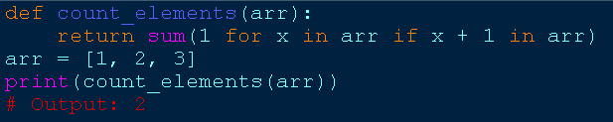

1. PERFORM STRING SHIFTS :

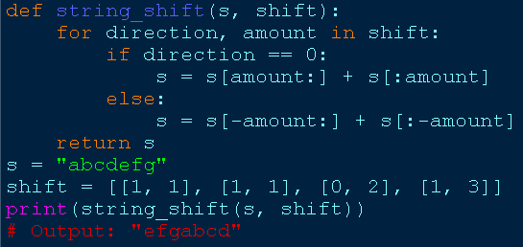

1. LEFTMOST COLUMN WITH AT LEAST A ONE :

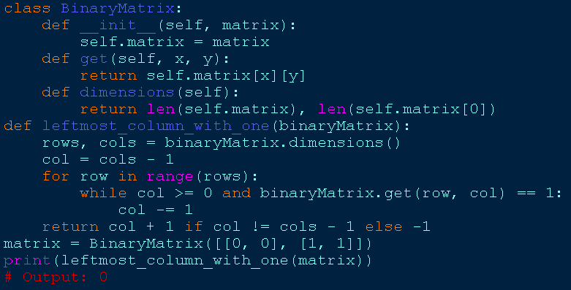

1. FIRST UNIQUE NUMBER :

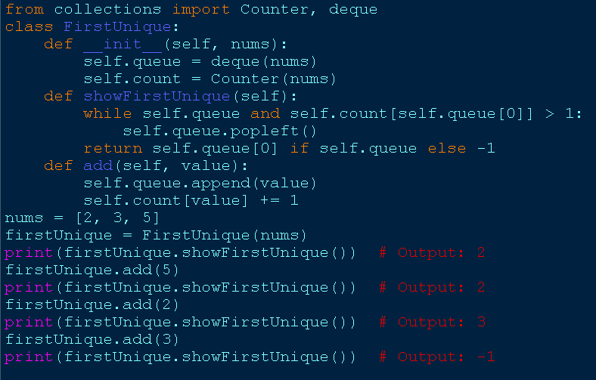

1. CHECK IF A STRING IS VALID FROM ROOT :

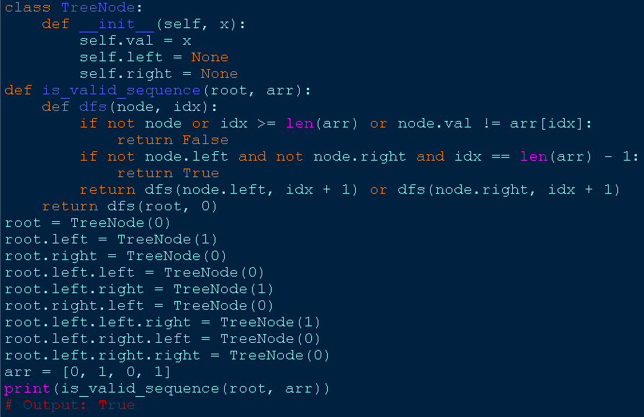

1. KIDS WITH THE GREATEST NUMBER OF CANDIES :

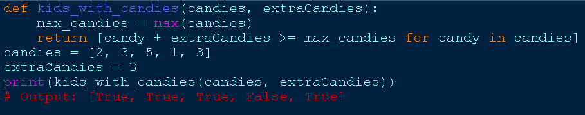

1. MAX DIFFERENCE YOU CAN GET FROM CHANGING AN INTEGER :

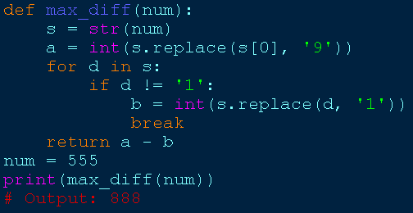

1. CHECK IF A STRING CAN BREAK ANOTHER STRING :

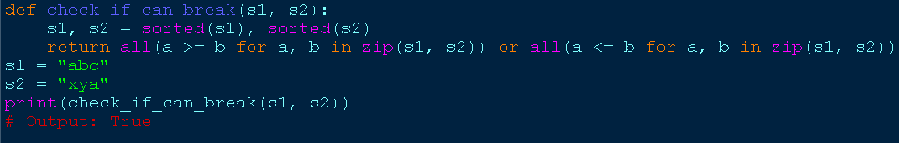

1. NUMBER OF WAYS TO WEAR DIFFERENT HATS :

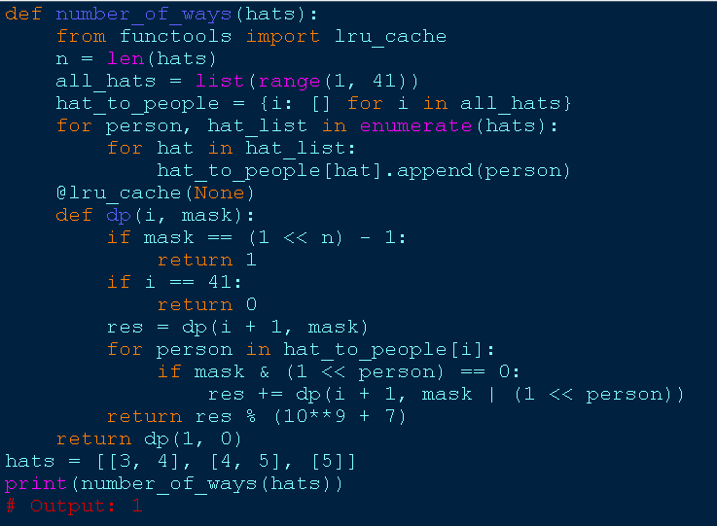

1. DESTINATION CITY :

